Receipt Submission Form

Submit Electronically, or mail to:

CSR Treasurer

c/o Office of Student Affairs, SOM E421

10900 Euclid Avenue

Cleveland, OH 44106-4966
Name: |  |  |  |  |  |  | Email: | @case.edu |  |  |  |  | Date:
 |  | (as you would like it to appear on the check)
Group: |  |  |  |  |  | Funding Approval #:
 |  |  | (if applicable)
Brief Event Description or reason for attending conference:  Additional Sources of Funding:  7 Digit Student ID (found on front page of your SIS profile):  Graduation Year: |  |  |  | 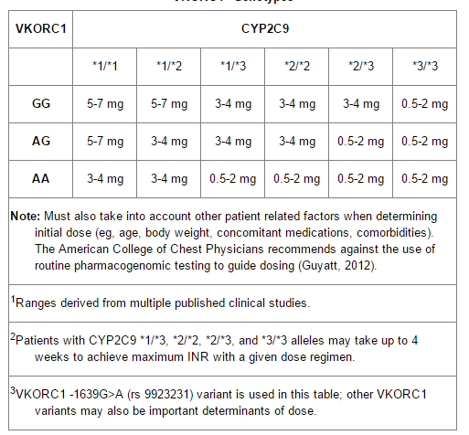
☐ | Your check will be automatically sent to your preferred address as listed in the SIS. Please log into SIS and change your preferred address to local rather than permanent if that is where you would like your check to be sent.
Please TAPE receipts in the space below or on the back of the form. Full page receipts may be stapled to the form. For individual funding, be sure to include proof of conference registration if applicable. Also, please make sure that you have included the itemized receipt as well as the credit card receipt, if applicable.
TREASURER USE ONLY – DO NOT FILL OUT OR OBSCURE |  |  |  |  | Purpose |  |  |  |  |  | Amount

